**DAILY ONLINE ACTIVITIES SUMMARY**

|  |  |  |  |  |  |  |  |  |
| --- | --- | --- | --- | --- | --- | --- | --- | --- |
| **Date:** | **20/06/2020** | | | | | **Name:** | **PRANEETA P HANDRAL** | |
| **Sem & Sec** | **4​th​ SEM. & ‘B’ SEC.** | | | | | **USN:** | **4AL19CS401** | |
| **Online Test Summary** | | | | | | | | |
| **Subject** | | **DATA COMMUNICATION** | | | | | | |
| **Max. Marks** | | **30** | | **Score** | | | **23** | |
| **Certification Course Summary** | | | | | | | | |
| **Course** | **Blockchain Essentials** | | | | | | | |
| **Certificate Provider** | | | **Cognitive class** | | **Duration** | | | **6 Hrs.** |
| **Coding Challenges** | | | | | | | | |
| **Problem Statement -1:** Write a C Program to rotate an array by K positions.  **Problem Statement -2:** Program that compares counting words in files using an Array List and a Map.  **Problem Statement -3:** Write a Java program to count number of bits to be flipped to convert A to B. | | | | | | | | |
| **Status:** **Executed.** | | | | | | | | |
| **Uploaded the report in Github** | | | | | **Yes** | | | |
| **If yes Repository name** | | | | | **LockdownCoding**  <https://github.com/praneetahandral/lockdowncoding> | | | |
| **Uploaded the report in slack** | | | | | **Yes** | | | |

**Online Test Summary: 18CS46 test was scheduled from 2:00 pm to 2:30pm. The portion for the IA was 3rd and 4th module there were 30 questions and the time assigned was 30 minutes the questions were mcq type. There were 30 questions of 1 marks respectively.**

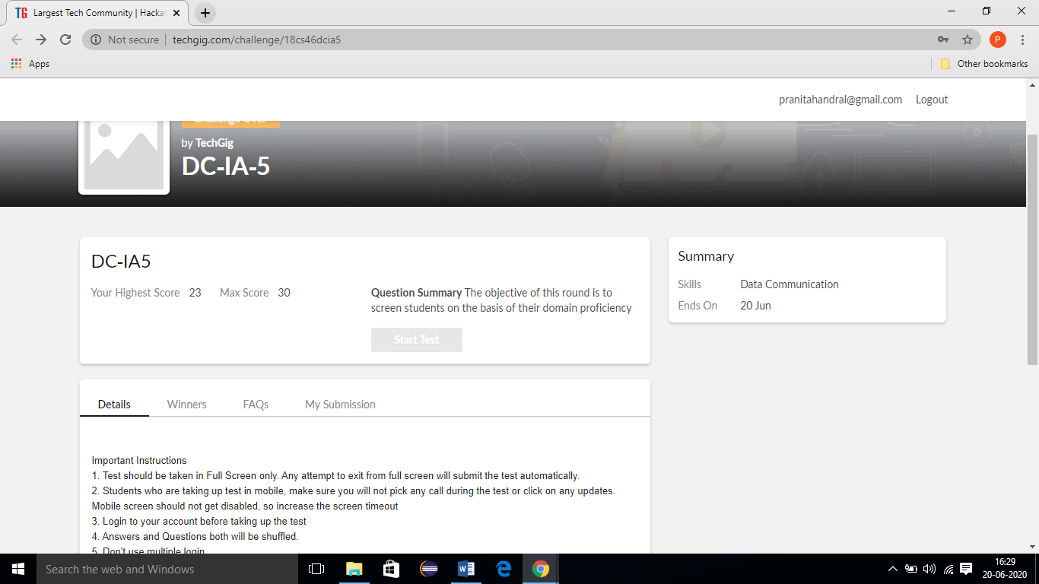

**Online Certification course Summary​:** I have taken my Online Certification Course in **Cognitive class**  the course which I have opted is **Blockchain Essentials**. Course contains videos, tutorials, assessments and quiz. Today I have gone through **Putting concepts into practice with an end-to-end demo**  and today I am attended the test for completion of course and also I get the 92% percentage in the test finally today I am complete the certification course **Blockchain Essentials** I received certification form **Cognitive class** and I put snapshot of the certificate below:

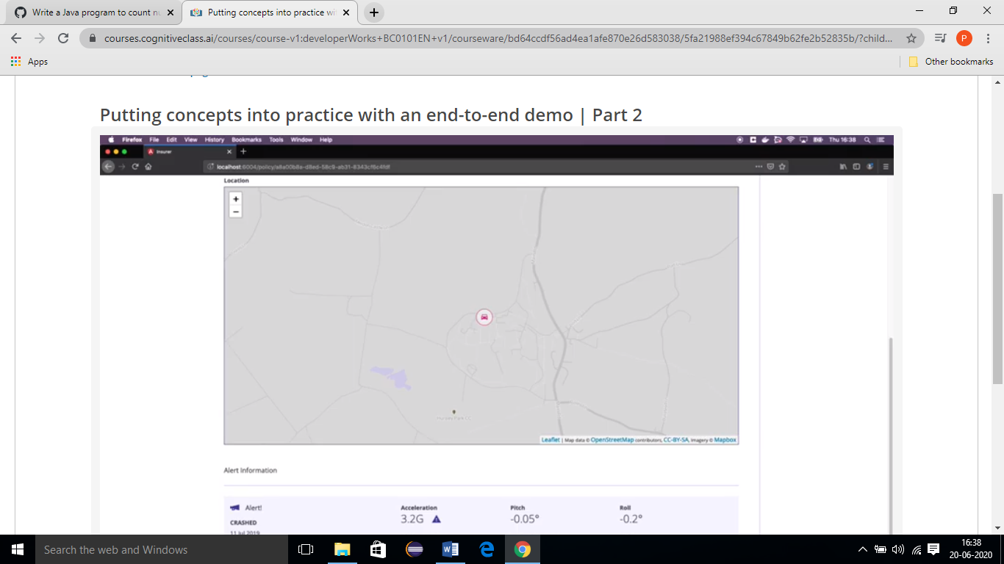

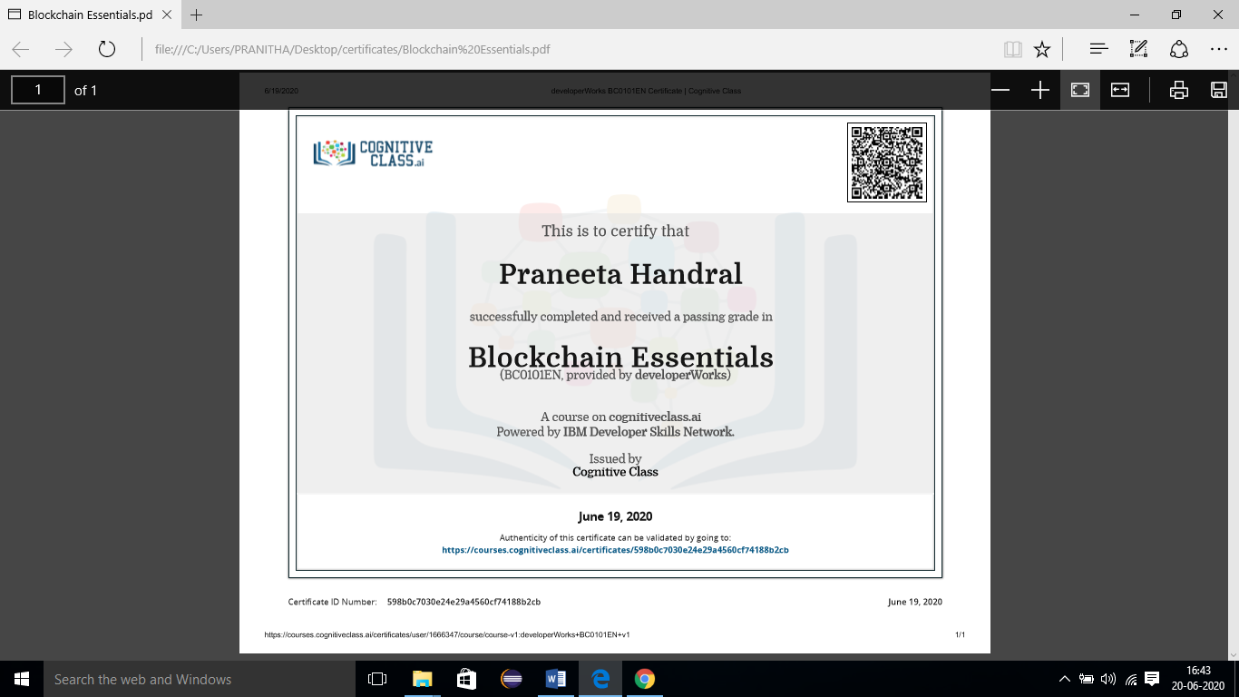

**Online Coding Summary​:** Today I received three programs one from prof. Venkatesh CSE Dept. and one from prof. Shilpa CSE Dept and another one from prof. vasudev CSE. I have written one program and uploaded it to my Github repository. This is my repository snapshot. I have uploaded the frequency program.

